**Assignment**

1. **Write a Java program to print the sorted list of integers by using one of the collection set**

**package** fundamnetals.java;

**import** java.util.*;

**public** **class** JavaFundamentals1

{

**public** **static** **void** main(String args[])

{

//creating an object of ArrayList class

ArrayList<Integer> list = **new** ArrayList<Integer>();

Scanner sc = **new** Scanner(System.***in***);

System.***out***.println("Enter number of input: ");

**int** n = sc.nextInt();

**int** m;

System.***out***.println("Enter integrs to sort: ");

**for** (**int** i = 0; i<n; i++)

{

m = sc.nextInt();

list.add(m);

}

//printing ArrayList before sorting

System.***out***.println("ArrayList Before Sorting:");

**for**(**int** marks: list)

{

System.***out***.println(marks);

}

//sorting ArrayList in descending order

Collections.*sort*(list, Collections.*reverseOrder*());

//printing ArrayList after sorting

System.***out***.println("ArrayList After Sorting:");

**for**(**int** marks: list)

{

System.***out***.println(marks);

}

}

}

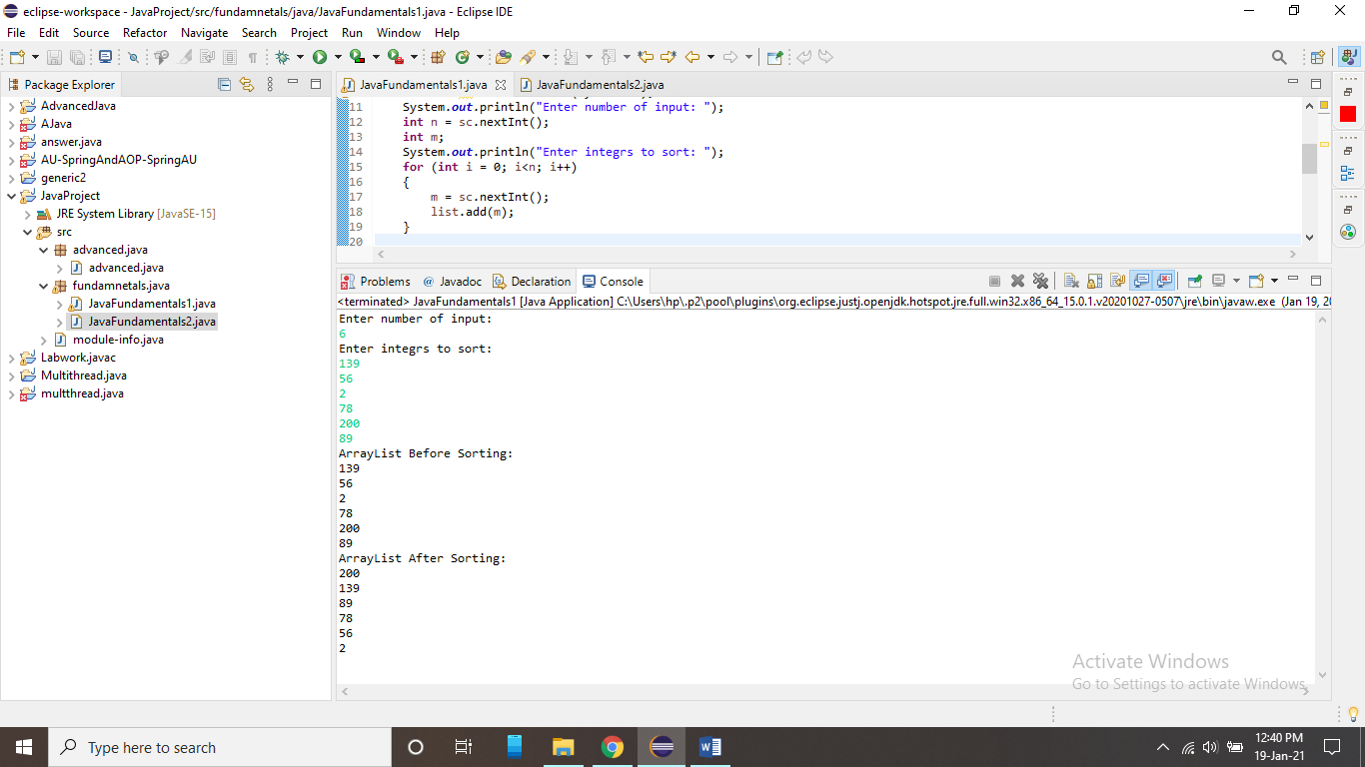

1. **Write a Java program to throw arithmetic exception using “throw” and “throws”**

**package** fundamnetals.java;

**import** java.io.*;

**public** **class** JavaFundamentals2

{

**static** **void** checkEligibilty(**int** stuage, **int** stuweight){

**if**(stuage<12 && stuweight<40) {

**throw** **new** ArithmeticException("Student is not eligible for registration");

}

**else** {

System.***out***.println("Student Entry is Valid!!");

}

}

**public** **static** **void** main(String args[]) **throws** IOException{

BufferedReader br = **new** BufferedReader(**new** InputStreamReader(System.***in***));

System.***out***.println("Welcome to the Registration process!!");

System.***out***.println("Enter Student age and weight");

**int** age = Integer.*parseInt*(br.readLine());

**int** weight = Integer.*parseInt*(br.readLine());

*checkEligibilty*(age, weight);

System.***out***.println("Have a nice day..");

}

}

